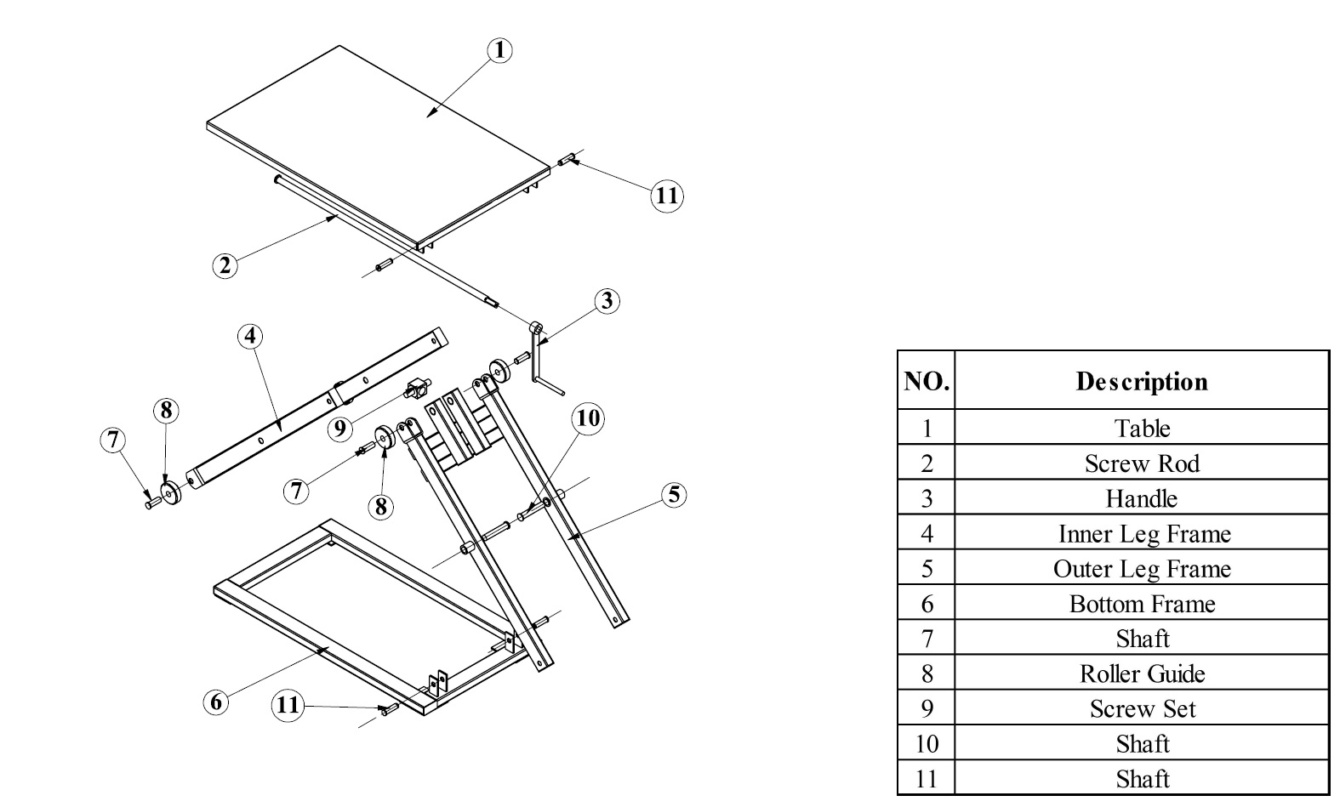
Parts list, lift table 50301/50302

